

**Computer Science Department**

**COMP133 ( Spring 2020 )**

**Project Phase Three (OPTIONAL) *Due Date: Tue (19/5/2020) by 10:00 pm (on Ritaj)***

In this phase, you need to add the book names (strings) to the functions you created in phase two as follows:

***you first need to add the following constant to phase two:***

***NAMESIZE (max size of a book name) equal to 50.***

The main function should add the following array to phase two:

***char names[MAXSIZE] [NAMESIZE];***

The functions will act the same but they will take the ***names*** array as a parameter and read/write names to files as well as print names to the screen.

***void displayMainMenu();*** // displays the main menu shown above

This function will remain similar to that in phase two.

***void uploadDataFile (char names[][NAMESIZE], int bins[], double prices[],int status[]);***

This function will be the same, but will also read the names from the file and add them to array ***names***.

***void addBook(char names[][NAMESIZE], int bins[], double pri ces[],int status[]);***

This function will remain the same as phase two, but when adding a book it will also ask the user to enter the name and will add it.

***void removeBook(char names[][NAMESIZE], int bins[], double prices[], int status[]);***

This function will remain the same, but will need to remove the name of the book as well as the other data ( by setting status = 0)

***void searchForBook(char names[][NAMESIZE], int bins[], double prices[], int status[]);***

This function will remain the same, but will need to print the name of the book with the other info if the book is found.

***void updateDataFile(char names[][NAMESIZE], int bins[], double prices[], int status[]);***

This function will remain the same, but will write the book names to the file books.txt as well as the other info.

***void printBooks (char names[][NAMESIZE], int bins[], double prices[], int status); // NEW FUNCTION***

This function will remain the same, but will also print the names of the books in addition to the other info to the screen.

***A book name may contain only letters, numbers, and underscore and must start with a letter (e.g. Introdcution_To_Computers, Computer_Programming_Fun, Geography_1 and so forth). You may assume that book names will NOT have any space characters in them.***

**Items that should be turned in by each student:**

1. ***A copy of your program code.***
2. ***An image file of a complete run similar to the output shown on page 4.***

***( To do this you can PrintScreen when you run your program and then paste into the paint program and then save it as an image file )***

1. Turn in your project phase by ***replying to the course coordinator’s message*** on Ritaj and attaching both your code file + run image file.
2. **Your name and id number should be included in the code file as a comment.**

***SAMPLE RUN:***

Make sure your program works **very similar** to the following sample run:

***Assuming that at the beginning of the run file books.txt has the following information stored:***

***Introduction_To_Geography*** 1234 72.45

***Computer_Fun*** 2345 25.20

***IMPORTANT NOTE: EVEN IF THE OUTPUT BELOW SHOWS THE PRINTED BOOKS IN SORTED ORDER YOU DON’T HAVE TO SORT THEM AND ANY ADDED BOOK CAN BE SIMPLY ADDED TO THE END OF THE LIST (IN THE ARRAYS OR FILES).***

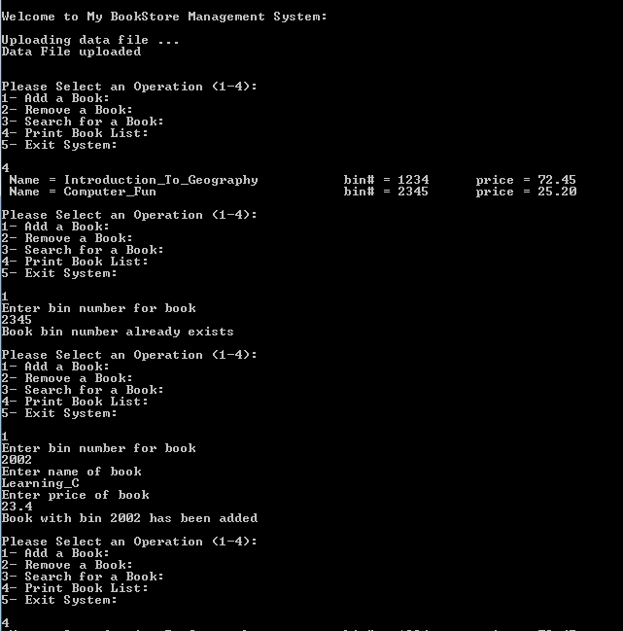

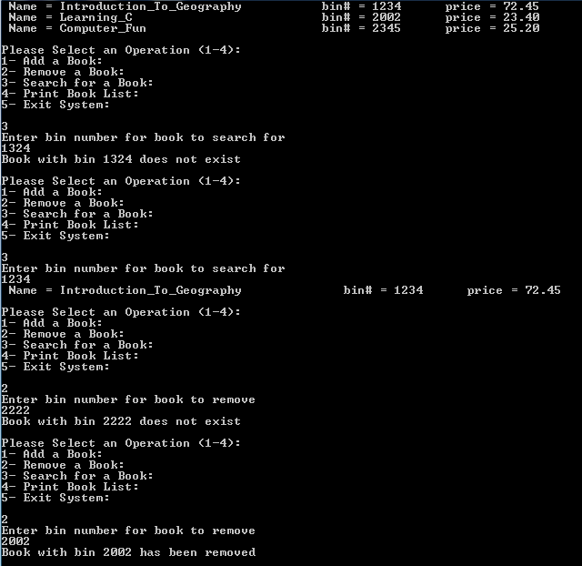

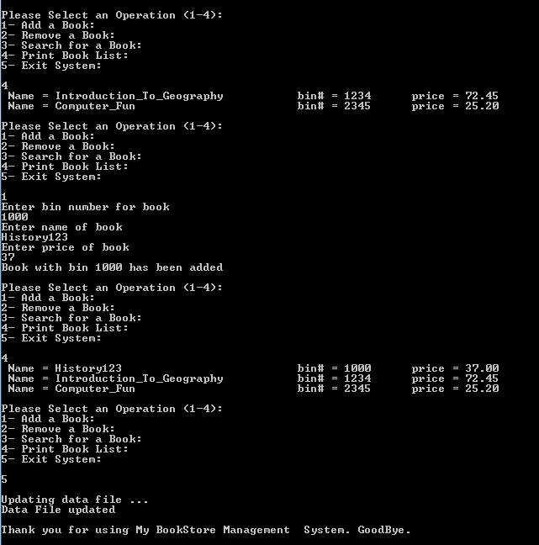

***Late project phases will not be accepted for any reason***.